**Fingerprint recognization**

**-----------------------------------------------------------------**

import java.awt.Image;

import java.awt.Toolkit;

import java.awt.image.PixelGrabber;

public class Compare {

static void processImage() {

String file1 = "p4.jpg";

String file2 = "p5.jpg";

Image image1 = Toolkit.getDefaultToolkit().getImage(file1);

Image image2 = Toolkit.getDefaultToolkit().getImage(file2);

try {

PixelGrabber grab1 =new PixelGrabber(image1, 0, 0, -1, -1, false);

PixelGrabber grab2 =new PixelGrabber(image2, 0, 0, -1, -1, false);

int[] data1 = null;

if (grab1.grabPixels()) {

int width = grab1.getWidth();

int height = grab1.getHeight();

data1 = new int[width * height];

data1 = (int[]) grab1.getPixels();

}

int[] data2 = null;

if (grab2.grabPixels()) {

int width = grab2.getWidth();

int height = grab2.getHeight();

data2 = new int[width * height];

data2 = (int[]) grab2.getPixels();

}

System.out.println("Fingerprint matches : " + java.util.Arrays.equals(data1, data2));

} catch (InterruptedException e1) {

e1.printStackTrace();

}

}

public static void main(String args[]) {

processImage();

}

}

/* OUTPUT

administrator@administrator-OptiPlex-3010:~/Desktop$ javac Compare.java

administrator@administrator-OptiPlex-3010:~/Desktop$ java Compare

Fingerprint matches : true

administrator@administrator-OptiPlex-3010:~/Desktop$

*/

[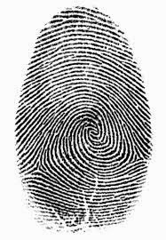](https://3.bp.blogspot.com/-SzEC4_Mouak/VJ0lmVwSoiI/AAAAAAAAAgI/FI2VMgCoTNo/s1600/p4.jpg)

[](https://3.bp.blogspot.com/-sJYs4NNe9HU/VJ0lmYba6HI/AAAAAAAAAgQ/NzSCmAxFjMA/s1600/p5.jpg)

[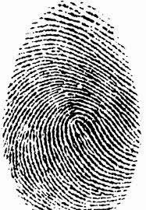](https://3.bp.blogspot.com/-0J6PoPKBy54/VJ0lmQuACsI/AAAAAAAAAgM/fd7vRYqvnbw/s1600/p6.jpg)